**SELECT queries 101**

**Exercise 1 - Tasks**

1. Find the title of each film.

1. Find the director of each film.

1. Find the title and director of each film.

SQL Query: **SELECT** title**,** director **FROM** movies**;**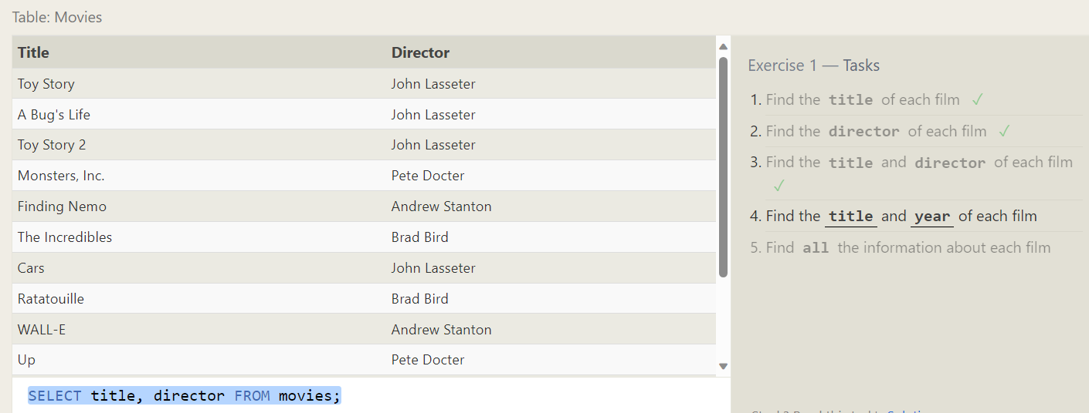

1. Find the title and year of each film.

1. Find all the information about each film.

SQL Query: **SELECT** title**,** director **FROM** movies**;**

**Queries with constraints**

**Exercise 2 – Tasks**

1. Find the movie with a row id of 6

**SQL Query: SELECT** **\*** **FROM** movies **WHERE** id **=** 6**;**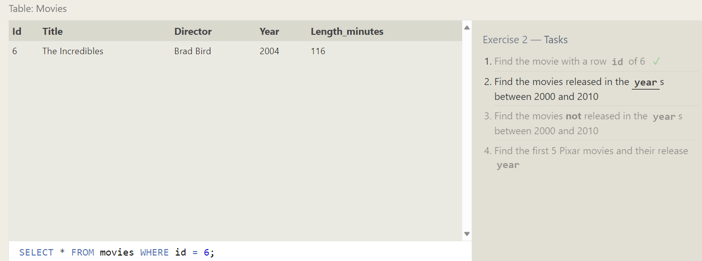

1. Find the movies released in the years between 2000 and 2010.

**SQL Query: SELECT** **\*** **FROM** movies **WHERE** year **BETWEEN** 2000 **AND** 2010**;**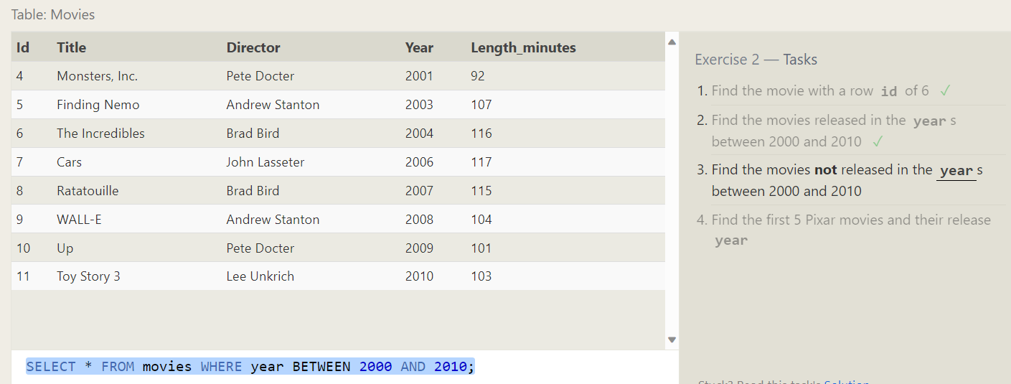

1. Find the movies not released in the years between 2000 and 2010

1. Find the first 5 Pixar movies and their release year.

**

**Queries with constraints (Pt. 2)**

**Exercise 3 – Tasks**

1. Find all the Toy Story movies.

**

1. Find all the movies directed by John Lasseter.

**

1. Find all the movies (and director) not directed by John Lasseter

**

1. Find all the WALL-* movies

**

**Filtering and sorting Query results**

**Exercise 4 – Tasks**

1. List all directors of Pixar movies (alphabetically), without duplicates

**SQL Query: SELECT** **DISTINCT** director **FROM** movies **ORDER** **BY** director **ASC;**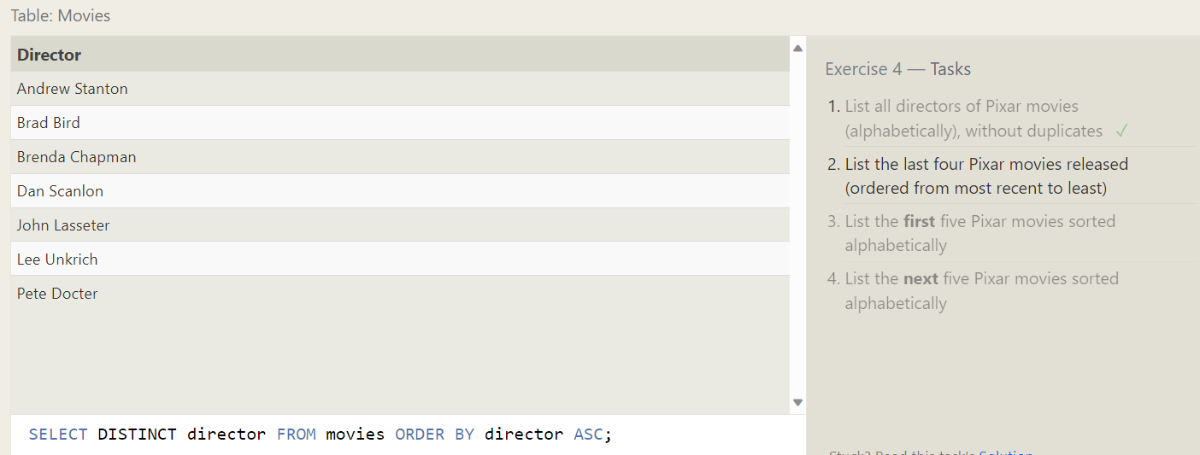

1. List the last four Pixar movies released (ordered from most recent to least)

**SQL Query: SELECT** **\*** **FROM** movies **ORDER** **BY** year **DESC** **LIMIT** 4**;**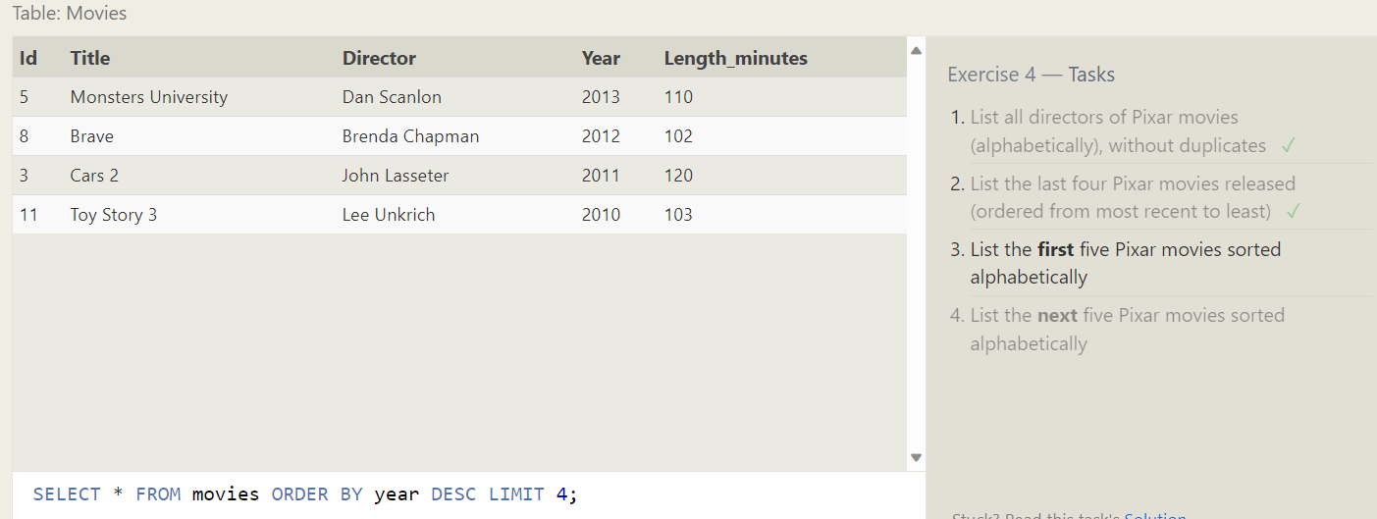

1. List the first five Pixar movies sorted alphabetically

**SQL Query: SELECT** **\*** **FROM** movies **ORDER** **BY** title **ASC** **LIMIT** 5**;**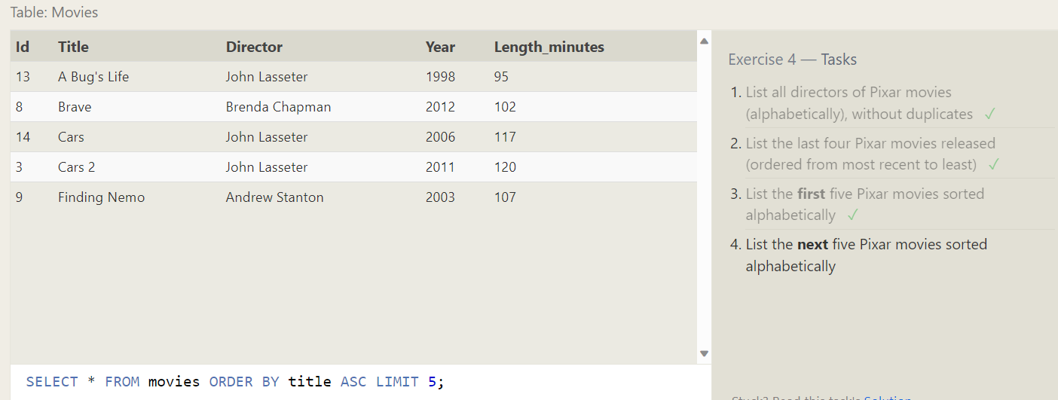

1. List the next five Pixar movies sorted alphabetically

**

**Simple SELECT Queries**

**Exercise 5 – Tasks**

1. List all the Canadian cities and their populations

SQL Query: **SELECT** city**,**population **FROM** north_american_cities **WHERE** country **=**"Canada"**;**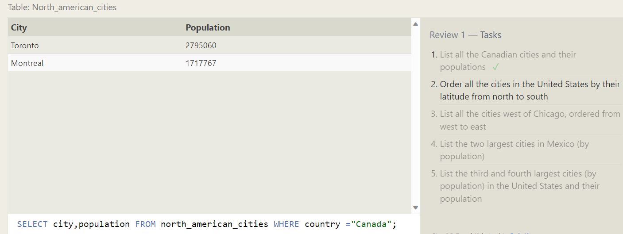

1. Order all the cities in the United States by their latitude from north to south

**

1. List all the cities west of Chicago, ordered from west to east

SQL Query : **SELECT** city**,** longitude **FROM** north_american_cities

**WHERE** longitude **<** -87.629798

**ORDER** **BY** longitude **ASC;**

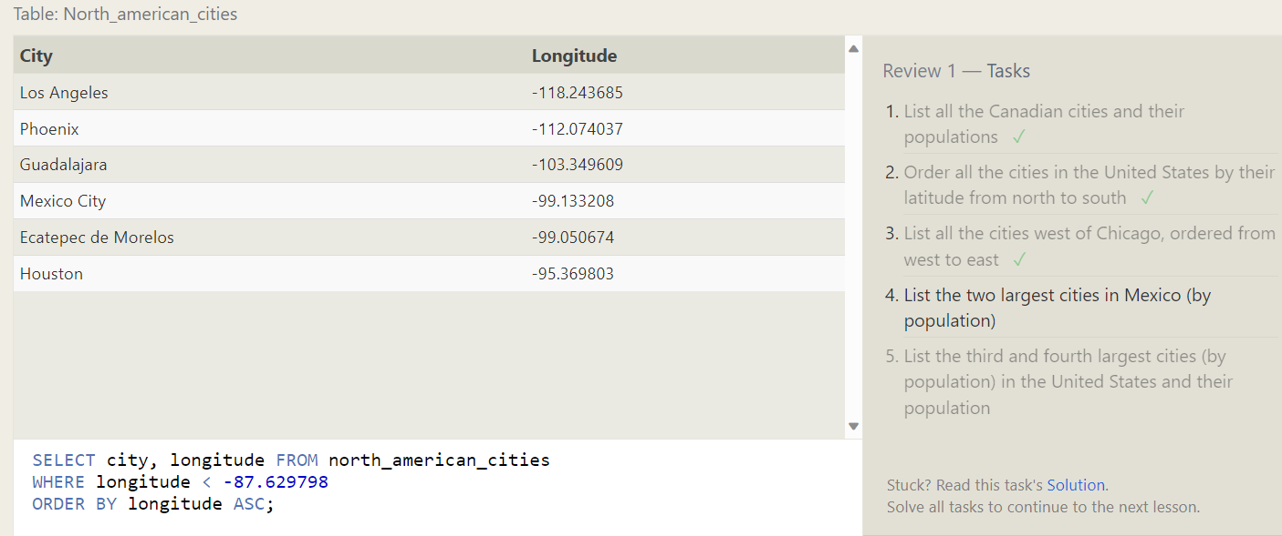

1. List the two largest cities in Mexico (by population)

1. List the third and fourth largest cities (by population) in the United States and their population

**Simple SELECT Queries**

**Exercise 6 – Tasks**

1. Find the domestic and international sales for each movie

SQL Query: **SELECT** title**,** domestic_sales**,** international_sales

**FROM** movies

**JOIN** boxoffice

**ON** movies**.**id **=** boxoffice**.**movie_id**;**

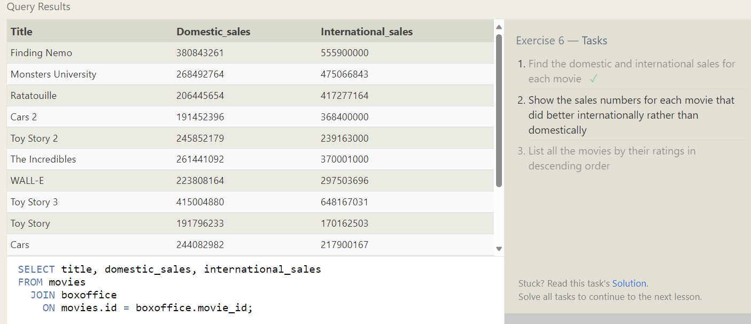

1. Show the sales numbers for each movie that did better internationally rather than domestically

SQL Query: **SELECT** title**,** domestic_sales**,** international_sales

**FROM** movies

**JOIN** boxoffice

**ON** movies**.**id **=** boxoffice**.**movie_id

**WHERE** international_sales **>** domestic_sales**;**

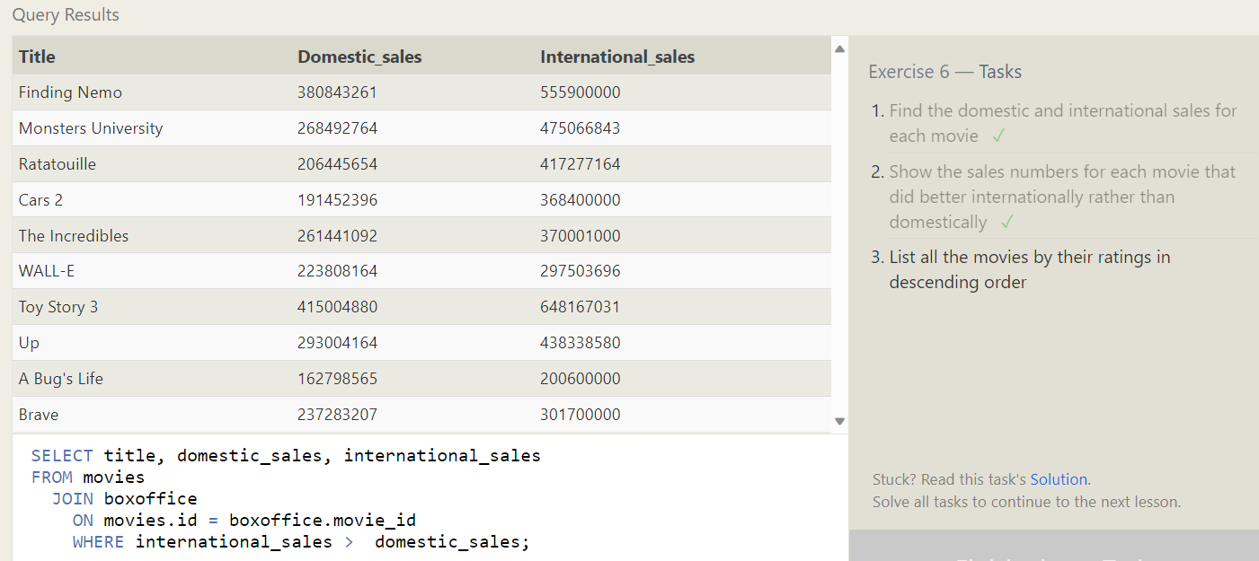

1. List all the movies by their ratings in descending order

SQL Query: **SELECT** title**,** director**,** year**,** rating

**FROM** movies

**JOIN** boxoffice

**ON** movies**.**id **=** boxoffice**.**movie_id

**ORDER** **BY** rating **desc**

**OUTER JOINs**

**Exercise 7 – Tasks**

1. Find the list of all buildings that have employees

SQL Query: **SELECT** **DISTINCT** Building_name

**FROM** employees

**LEFT** **JOIN** Buildings

**ON** Buildings**.**Building_name **=** Employees**.**Building**;**

1. Find the list of all buildings and their capacity

SQL Query: **SELECT** **DISTINCT** Building_name **,** capacity

**FROM** employees

**LEFT** **JOIN** Buildings**;**

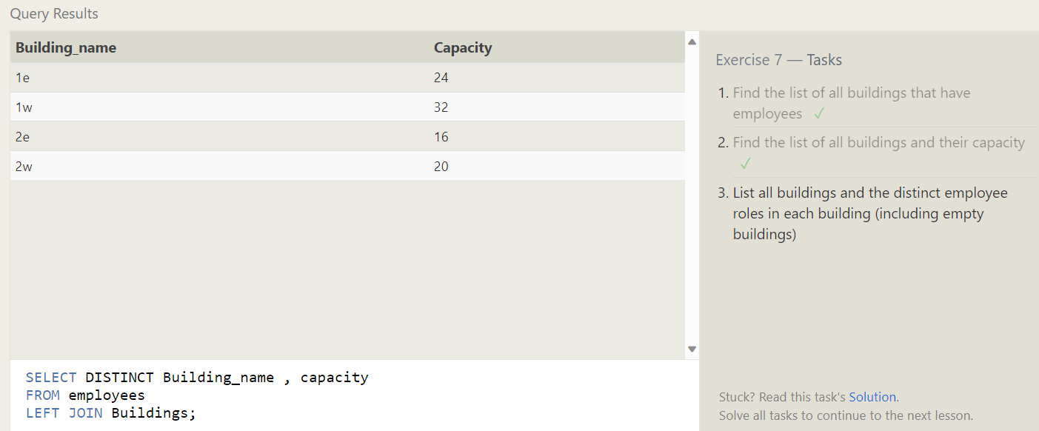

1. List all buildings and the distinct employee roles in each building (including empty buildings)

SQL Query: **SELECT** **DISTINCT** building_name**,** role

**FROM** buildings

**LEFT** **JOIN** employees

**ON** building_name **=** building**;**

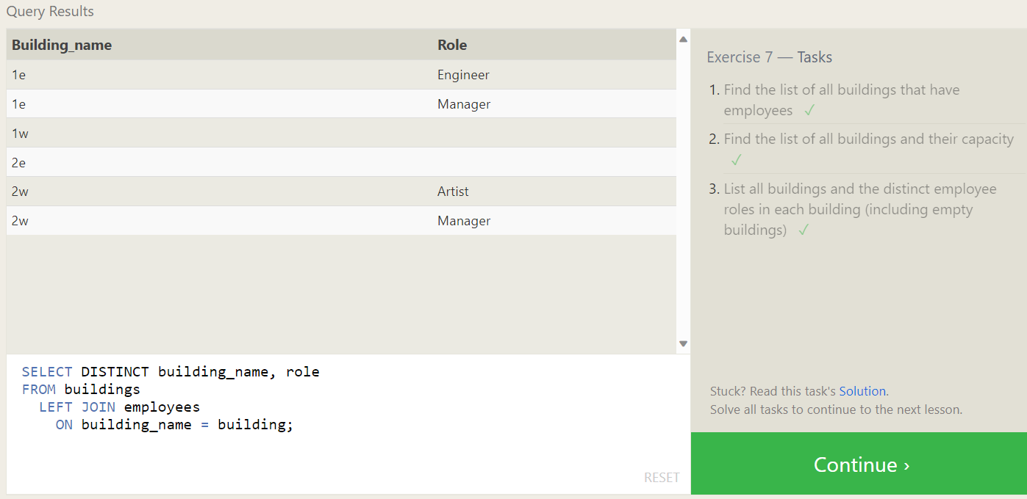

**A short note on NULLs**

**Exercise 8 – Tasks**

1. Find the name and role of all employees who have not been assigned to a building

SQL Query: **SELECT** name**,** role

**FROM** employees

**Where** building **IS** **NULL;**

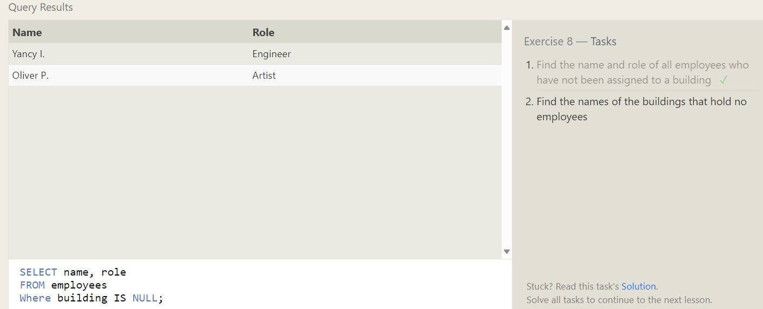

1. Find the names of the buildings that hold no employees

SQL Query: **SELECT** **\*** **FROM** buildings

**left** **join** Employees

**on** Building_name **=** Building

**WHERE** name **IS** **NULL** **;**

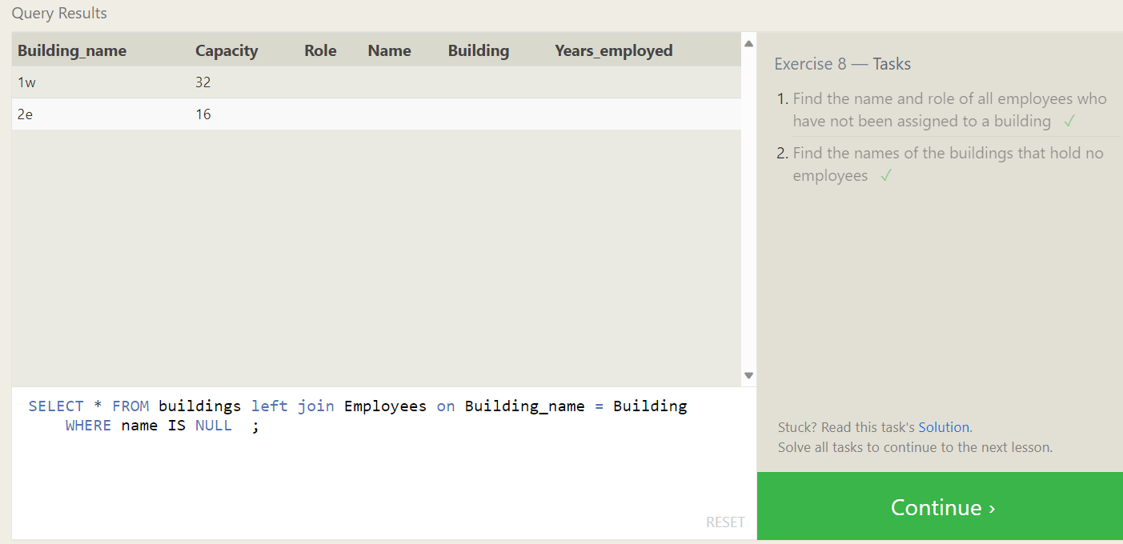

**Queries with expressions**

**Exercise 9 – Tasks**

1. List all movies and their combined sales in millions of dollars

SQL Query: **SELECT** title**,** **(**Domestic_sales **+** International_sales**)** **/** 1000000 **as** SALES **FROM** movies **LEFT** **JOIN** boxoffice **on** id **=** movie_id**;**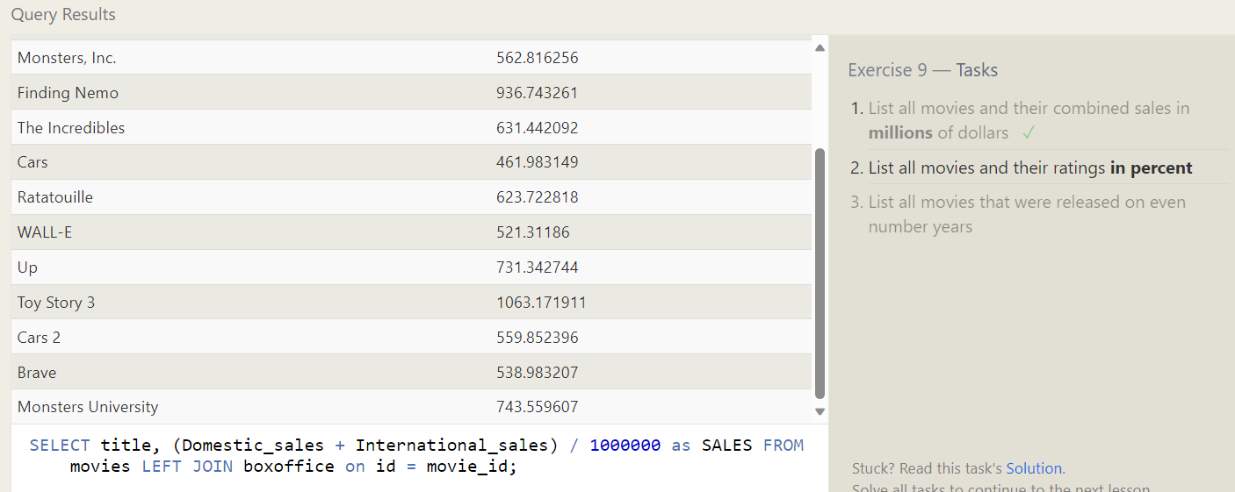

1. List all movies and their ratings in percent

SQL Query: **SELECT** title**,** rating**,** **(**rating **\***10**)** **AS** **percent** **FROM** movies **LEFT** **JOIN** BoxOffice **ON** id **=** movie_id**;**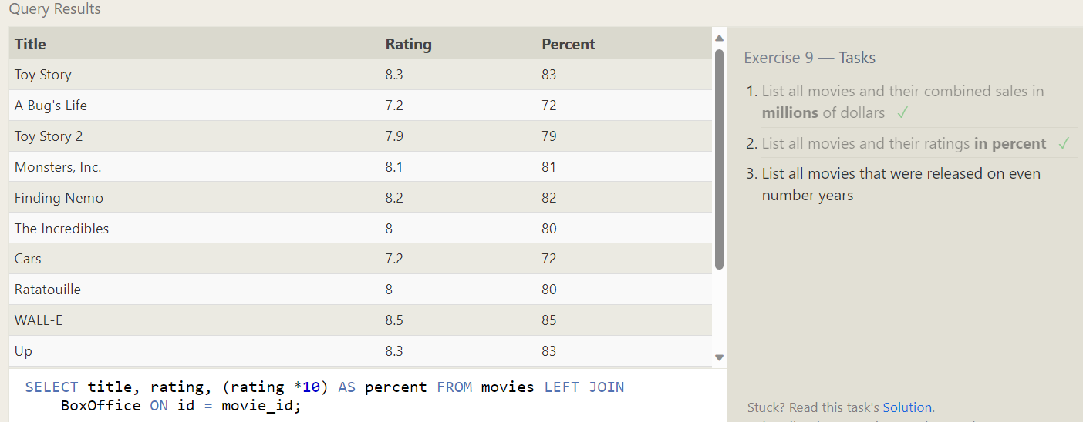

1. List all movies that were released on even number years

SQL Query: **SELECT** title**,** director**,** year **FROM** movies **WHERE** year**%**2 **=** 0**;**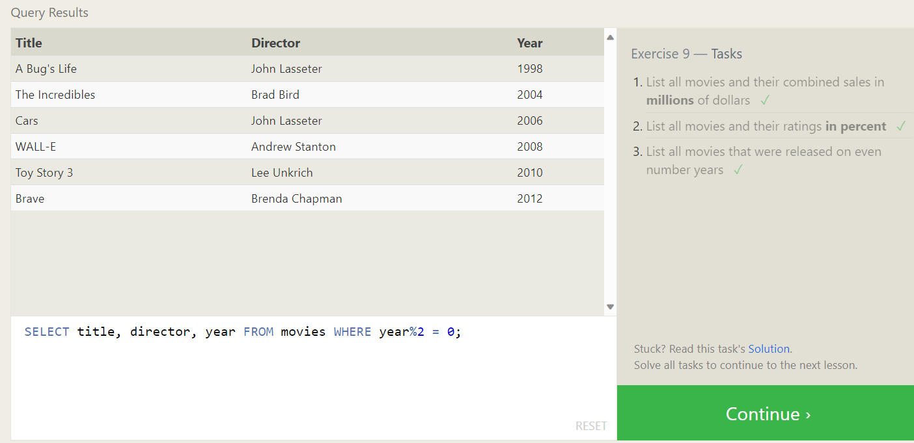

**Queries with aggregates (Pt. 1)**

**Exercise 10 – Tasks**

1. Find the longest time that an employee has been at the studio

1. For each role, find the average number of years employed by employees in that role

1. Find the total number of employee years worked in each building

**Queries with aggregates (Pt. 2)**

**Exercise 11 – Tasks**

1. Find the number of Artists in the studio (without a HAVING clause)

SQL Query: **SELECT** role**,** **count(**role**)** **as** no_of_artist **FROM** employees **where** role **=** "Artist"**;**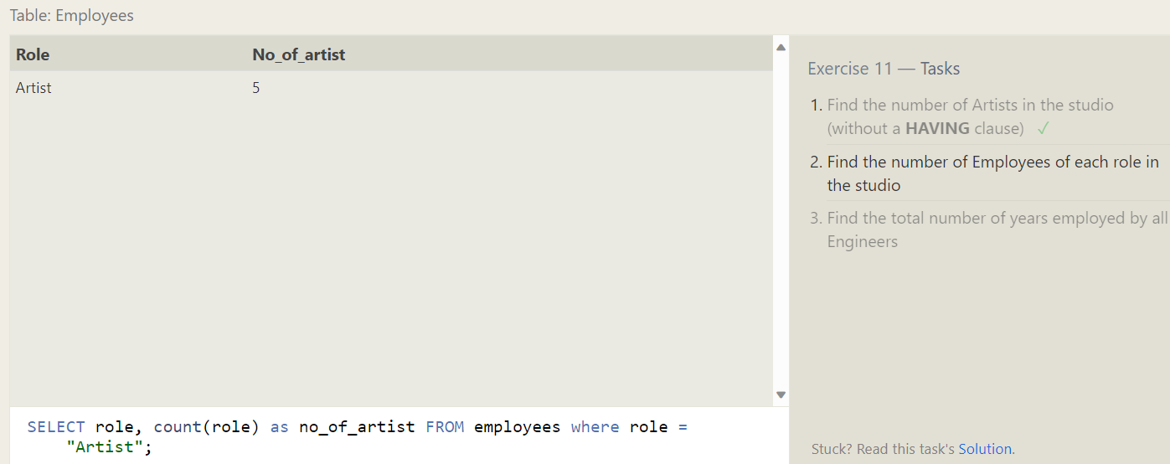

1. Find the number of Employees of each role in the studio

1. Find the total number of years employed by all Engineers

SQL Query: **SELECT** role**,** **sum(**Years_employed**)** **as** total_year **FROM** employees **group** **by** role **having** role **=** "Engineer"**;**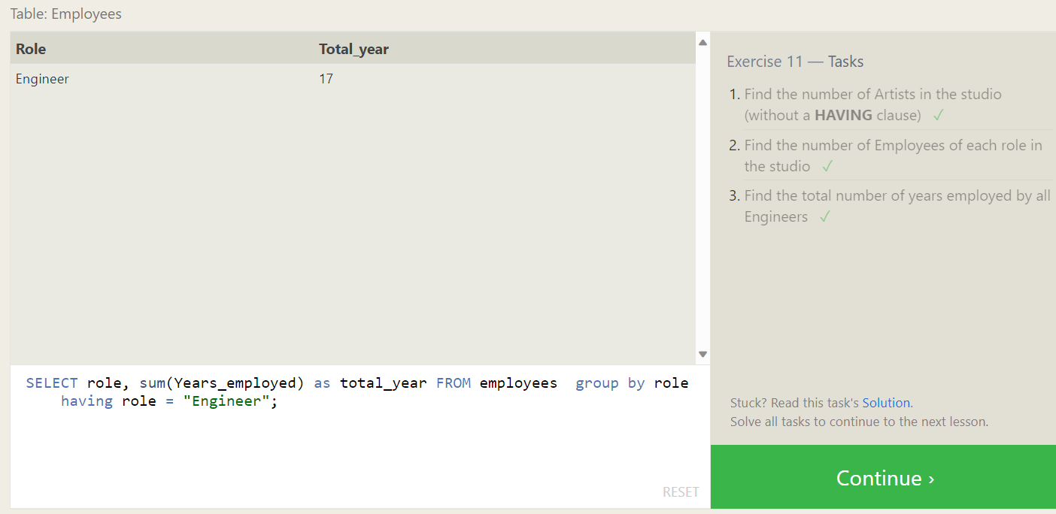

**Order of execution of a Query**

**Exercise 12 – Tasks**

1. Find the number of movies each director has directed.

SQL Query: **SELECT** director**,** **count(**title**)** **as** no_of_movies **FROM** movies **group** **by** director**;**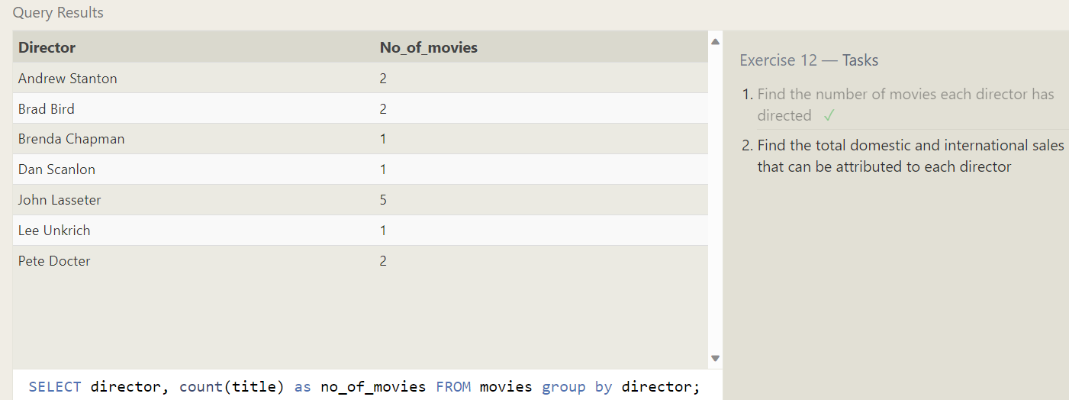

1. Find the total domestic and international sales that can be attributed to each director.

SQL Query: **SELECT** director**,**Domestic_sales**,**International_sales**,**

**sum(**Domestic_sales **+** International_sales **)** **as** total_sales

**FROM** movies

**LEFT** **JOIN** Boxoffice

**on** id **=** movie_id

**group** **by** director**;**

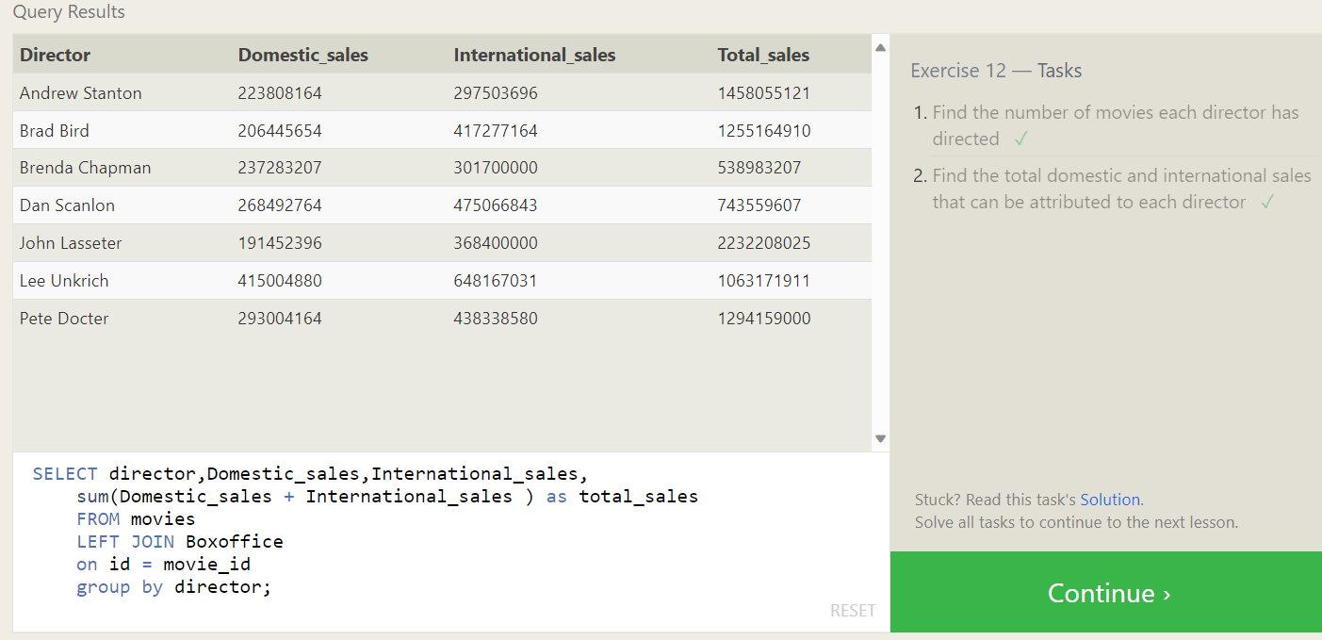

**Inserting rows**

**Exercise 13 – Tasks**

1. Add the studio's new production, Toy Story 4 to the list of movies (you can use any director)

1. Toy Story 4 has been released to critical acclaim! It had a rating of 8.7, and made 340 million domestically and 270 million internationally. Add the record to the BoxOffice table.

SQL Query: **insert** **into** boxoffice **values(**14**,**8.7**,**340000000**,**270000000**);**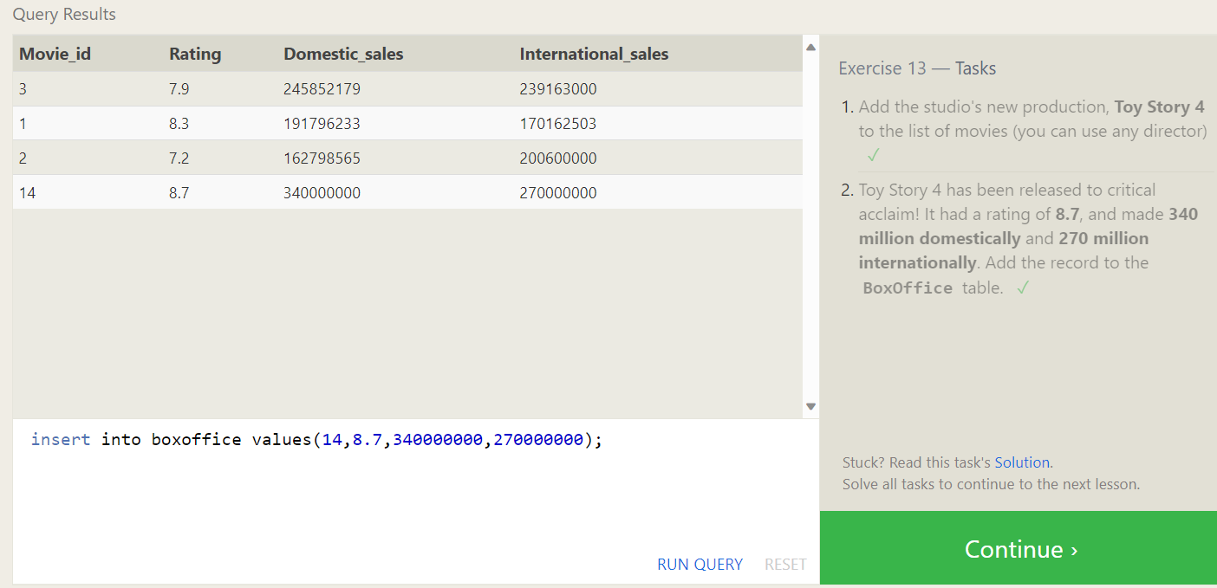

**Updating rows**

**Exercise 14 – Tasks**

1. The director for A Bug's Life is incorrect, it was actually directed by John Lasseter.

SQL Query: **UPDATE** movies **set** director **=** "John Lasseter" **where** id **=** 2 **;**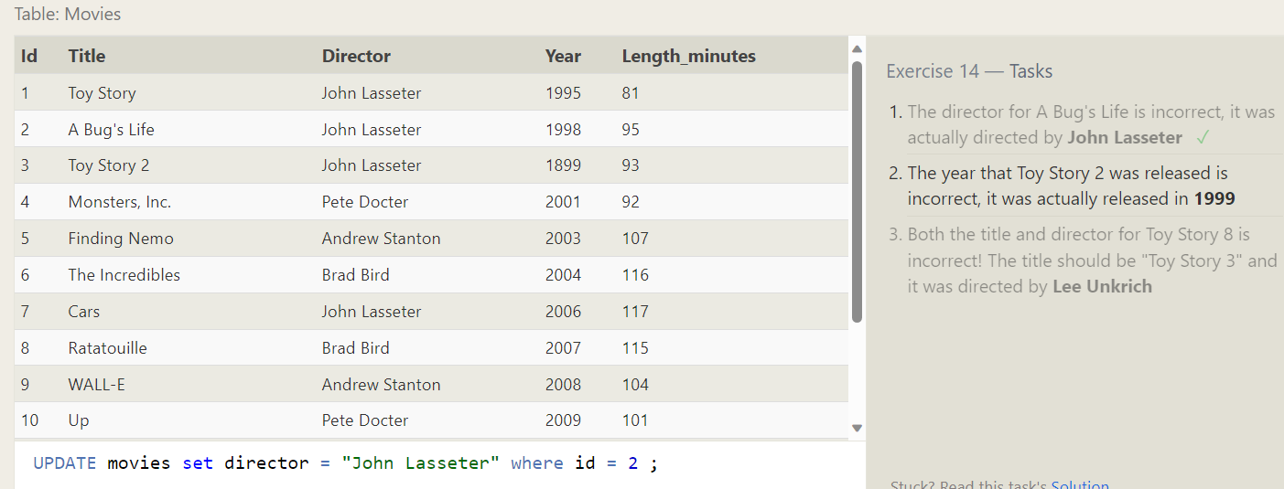

1. The year that Toy Story 2 was released is incorrect, it was actually released in 1999

SQL Query: **UPDATE** movies **set** year **=** 1999 **where** title **=** "Toy Story 2"**;**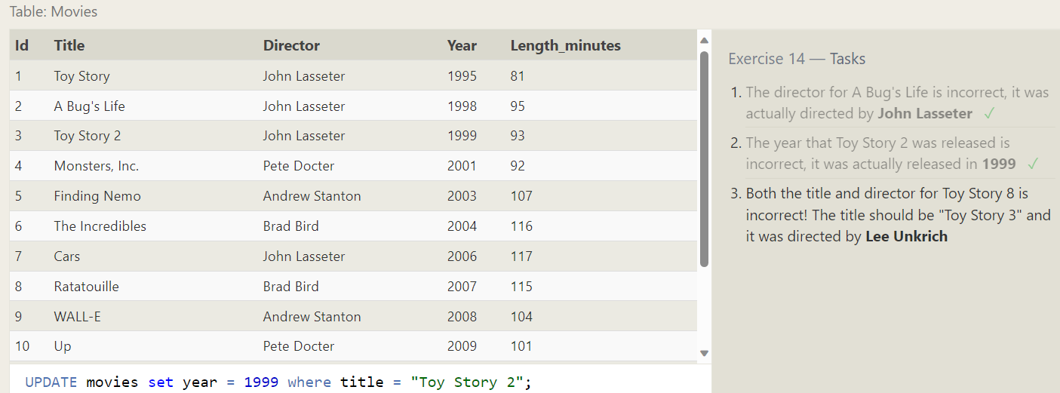

1. Both the title and director for Toy Story 8 is incorrect! The title should be "Toy Story 3" and it was directed by Lee Unkrich

SQL Query: **UPDATE** movies **set** title **=** "Toy Story 3"**,** director **=** "Lee Unkrich" **where** id **=** 11**;**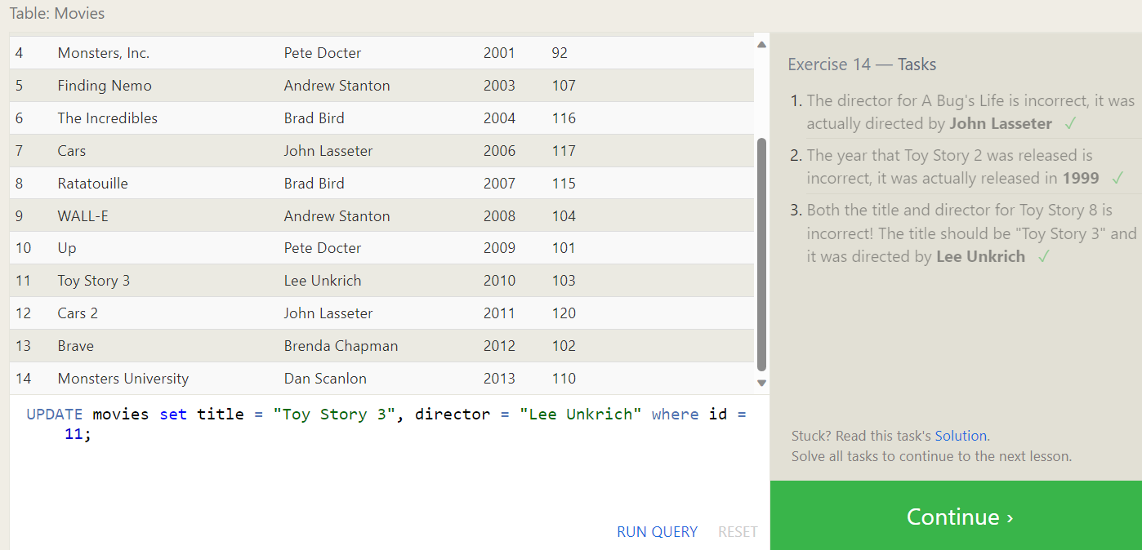

**Deleting rows**

**Exercise 15 – Tasks**

1. This database is getting too big, lets remove all movies that were released before 2005.

1. Andrew Stanton has also left the studio, so please remove all movies directed by him.

SQL Query: **delete** **FROM** movies **where** director **=** "Andrew Stanton"**;**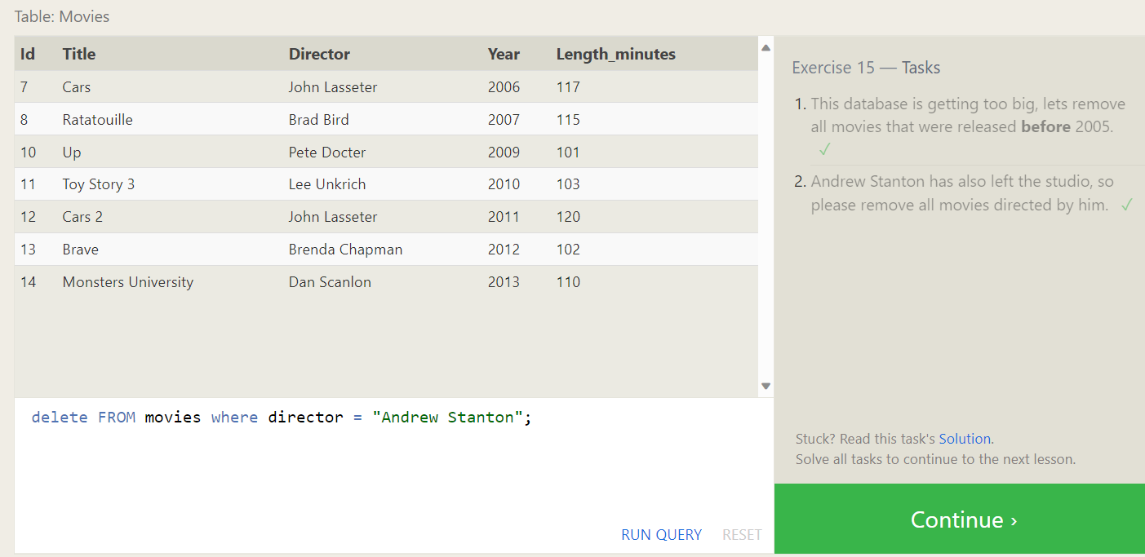

**Creating tables**

**Exercise 16 – Tasks**

1. Create a new table named Database with the following columns:
   1. – Name A string (text) describing the name of the database
   2. – Version A number (floating point) of the latest version of this database
   3. – Download_count An integer count of the number of times this database was downloaded
   4. This table has no constraints.

SQL Query: **create** **table** **Database(**

id integer**,**

Name varchar**(**30**),**

Version float**,**

Download_count integer

**)**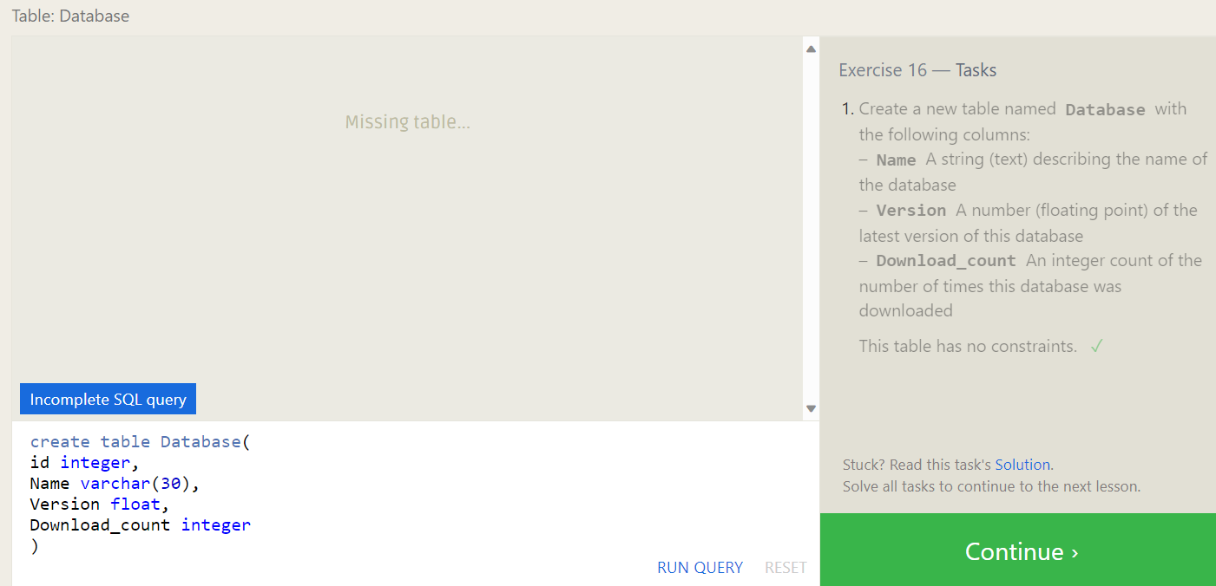

**Altering tables**

**Exercise 17 – Tasks**

1. Add a column named Aspect_ratio with a FLOAT data type to store the aspect-ratio each movie was released in.

SQL Query: **alter** **table** movies **add** **column** Aspect_ratio float**;**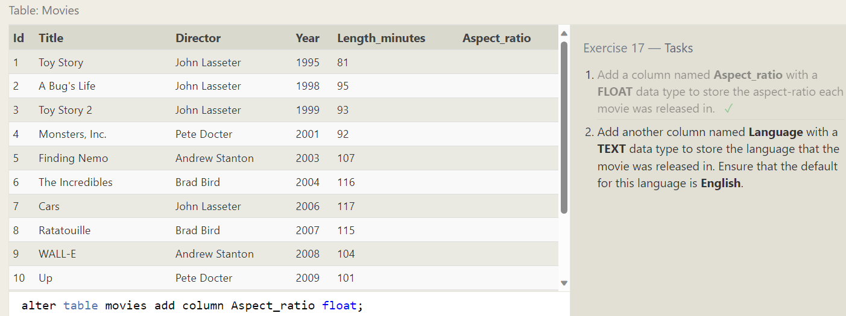

1. Add another column named Language with a TEXT data type to store the language that the movie was released in. Ensure that the default for this language is English.

**Dropping tables**

**Exercise 18 – Tasks**

1. We've sadly reached the end of our lessons, lets clean up by removing the Movies table.

SQL Query: **drop** **table** **if** **exists** movies**;**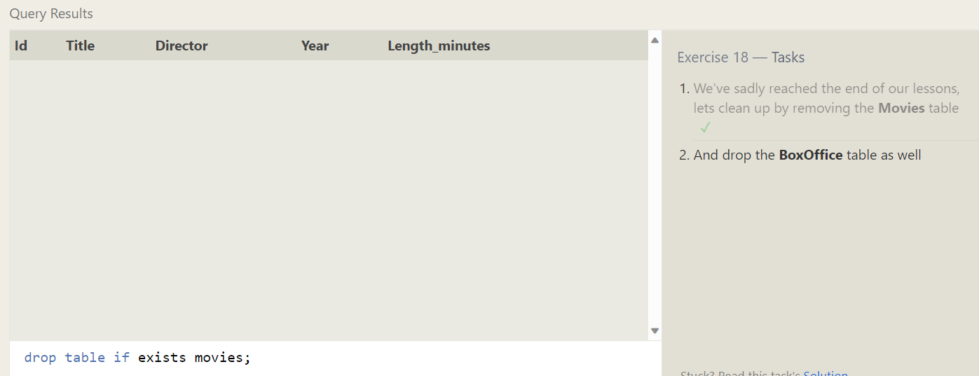

1. And drop the BoxOffice table as well

